**Solution Design**

**Project Reporting/Monitoring**

ERP Success Partners Inc.

1-833-377-7701  
**[www.erpsuccesspartners.com](http://www.erpsuccesspartners.com)**

**Canada, USA & EMEA**

|  |  |
| --- | --- |
| Client: | **EITUM** |
| Effective Date: | **5th October 2023** |
| Created by: | **Naiwen LIU** |
| Solution by: | **Naiwen LIU, Hamilton Nieri** |
| Estimated effort: |  |

# Business Context

Once the CFP Application Form is approved, the project monitoring starts. EITUM allows the partner or leader partner to change some of the elements on the Application from. There are 2 kinds of changes: minor change and major change.

# Requirements

The PMO team should be capable to follow all the changes on the CFP application form.

# Use Cases

## Use Case 1: Minor Change (No Approval Flow)

##### Assumptions

The CFP Application is approved.

The PMO and Project Manager has access to NetSuite.

PMO and Project Manager are not empty on CFP Application Form

The mentioned field should be editable by Leader partner.

Budget record is not empty.

Task Record is not empty

Milestones are not empty

Deliverables are not empty

Outputs are not empty

KPIs are not empty

##### Scenario:

Once the application form is approved, a new button “Project Change Request” will appear on the top of the application form in customer center.

The project Leader should have the possibility to edit the fields on the online form.

* The contact of partner Involved in the project
* Expected Date on the Deliverable Tab on CFP Application Form
* On the Budget Tab,
* Changes in budget distribution between cost categories at partner level lower than +/- 30% (for example, an individual partner shifting 30% of their own travel budget to personnel). except for the change in “Subcontracting” tab.

If the partner increases its total budget (and therefore the total budget for the whole project) we consider it’s a major change (see the case in the major change). Stated otherwise, change of budget between partners is always a major change.

When the leader Partner submitting the online form, a mandatory textbox where to include a brief explanation of the changes applied (the partners to provide a justification of what they ask).

Once the above changes have been saved, NetSuite sends a mail to the Project Manager in the Thematic Area should be notified by mail, listing the name of field which has been changed with the new value and old value.

No approval process is needed in this case, the CFP Application Form stays in “Approved” status.

The system should store the old versions, the new approved version becomes the official one. All the future modifications will be on this new version.

## Use Case 2: Major Change (Approval Flow)

##### Assumptions

The CFP Application is approved.

The PMO and Project Manager has access to NetSuite.

PMO and Project Manager are not empty on CFP Application Form

The mentioned field should be editable by Leader partner.

Budget record is not empty.

Task Record is not empty

Milestones are not empty

Deliverables are not empty

Outputs are not empty

KPIs are not empty

##### Scenario

Once the application form is approved, a new button “Project Change Request” will appear on the top of the application form in customer center.

The Leader Partner should have the possibility to edit the fields on the online form:

* The content and number of tasks
* The content and number of milestones
* The content and number of deliverables, outputs and KPIs
* The description of the project
* Changes in the project Partner:
  + Partner(s) leaving the project
  + New partner(s) being added to the project

1. Changes in budget distribution between cost categories at partner level higher than +/- 30% ((for example, an individual partner shifting more than30% of their own travel budget to personnel)

Example below of major changes:

|  |  |  |  |
| --- | --- | --- | --- |
|  | original budget | new budget | comment |
| personnel | € 100,000.00 | € 132,000.00 | it's more than +30% |
| travel | € 10,000.00 | € 14,000.00 | it's more than +30% |
| other goods | € 10,000.00 | € 5,000.00 | it's more than -30% |
| subcontracting | € 10,000.00 | € 10,500.00 | it's more than the original budget |

* Redistribution of budget between partners: Distribute one of the budgets of Partner 1 to Partner 2
* Increase/decrease of the subcontracting budget-line (any amount)
* Decrease/increase of the overall project budget
* Changes to the project end date on CFP Application Form

When the leader Partner submitting the online form, a mandatory textbox where to include a brief explanation of the changes applied (EITUM needs the leader partner to provide a justification of what they ask).

Once one of the above changes have been done, the CFP Application Form’s status changes to “Approve with condition”.

* Project Manager should be notified when a change request has been submitted.
* The modified value will be in red
* The modified part will be in a section of the application form when the status of form is “pending approval”. Once these modifications have been approved, the status of form changes back to “approved”, this section will disappear.
* Project Manager should approve the modifications (red parts).
* Project Manager should have the possibility to include comments/remarks when approving/rejecting/send back for modifications.
* In case of rejection, the Project Leader should be notified that the modification has been rejected and he can see the reject reason.
* In case approval: The system should store the first version of the application form, but the new version should become the official one (replacing the first one).

New changes will be applied on the latest version, not on the original one.

* In case of “send back for modifications”: the project leader should be notified additional action is needed from his side and see the comments of the project manager.

Implementation of Use Case #1 and #2:

1. If the CFP App status is Approved and the current logged in user is Project Lead Partner, then add the custom action button “Project Change Request” to the online form header.
2. Once it is hit by the user, the fields and sub records listed above and below will be enabled for editing and the Submit button will replace the “Project Change Request” button at the top of the page.
3. When the user clicks on the Submit button and then inputs the change request reason, it will append a body parameter that indicates this is the project change request and submits the form to the backend script.
4. The backend script is required to log all the changes and check whether the current project change request is major or minor based on the rules above and below.
5. The backend script will create a new CFP App record and send an email notification to the Project Manager.

* If it is a minor change, the new CFP App record will have the “Is Official?” checkbox enabled and the higher minor version number (E.g., version 1.0 to 1.1) and the status of “Approved”.
* If it is a major change, the new CFP App record will have the “Is Official?” checkbox cleared and the higher major version number (E.g., version 2.1 to 3.0) and the status of “Pending Approval”.

A custom action button “Review Changes” will be made visible to project managers on the CFP App form.

When the button is clicked, the user will be brought to a new script-generated page where he can see all the differences from the official version of the CFP App Form.

There will be “Approve”, “Reject”, “Send back for modification” custom action buttons at the top of the page.

Reject reason can be at field and sub record entry levels as well as body level.

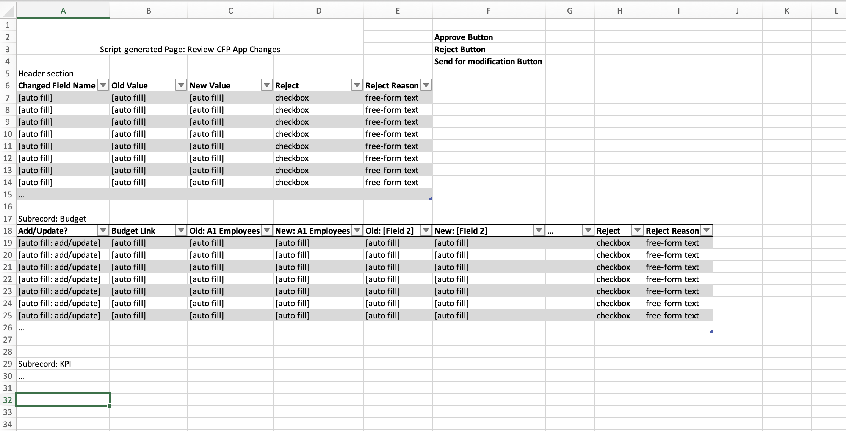

In case of rejection, the lead partner will receive a notification that contains rejected fields and child record entries with reasons.

In case of approval, the lead partner will be notified of the new status.

In case of approval with conditions, the lead partner will be notified of an instruction.

## User Case 3: Reporting of KPI and Deliverables section

Assumptions

PMO and Project Manager has access to NetSuite.

PMO and Project Manager are not empty on CFP Application Form

The mentioned fields are editable by Leader partner.

Deliverables section are not empty

Outputs section are not empty

KPIs section are not empty

##### Scenario

Lead Partner can report the deliverables or KPIs on the CFP Application Form by the established due date stated in their approved project proposal. In the application form, when the lead partner includes the KPIs and DELs they always must indicate the delivery date. Once the project is approved this should remain visible (ideally there should be a “reporting” tab/section where it will be possible to report KPIs, DELs, costs, activity report (interim and final). When the due date is approaching, the lead partner should receive a notification: for DELs and KPIs it could be 1 week before the deadline.

When submitting a deliverable/KPI, the system should be able to do the following restriction:

The Project Leader should upload the deliverable or KPI by entering the reporting tab/section to start to fill in the following fields according to the KPI type selected during the CFP application circle.

* Completion Date
* Comments (in case there is a comment is added)
* Possibility to upload a document (for all DELs and some KPIs it should be mandatory to upload a document)
* In the case of the KPIs: the “structured data” form should be filled in (mandatory) [these info are in the KPIs Excel]

Then they click the “submit” button to submit the modification.

The Project Manager of the Application form should be notified that a new deliverable/KPI is submitted.

The Project Manager reviews the deliverable/KPI, he can approve or reject it

* Approve: The Project Manager can put the comments. This action must be reversible – i.e. in a second moment the project manager should still be able to reject a previously approved KPI.
* Reject: Lead Partner should be notified once the rejection and should be able to read the comments/remarks. The Project Leader should be able to edit the deliverable/KPI and submit it once again. The approval process restart.

Once a KPI is approved PMO and Milena Zoppeddu [milena.zoppeddu@eiturbanmobility.eu](mailto:milena.zoppeddu@eiturbanmobility.eu) should receive a notification. PMO and Milena do not need to approve this KPI but must know that is available. It can happen that, some time after the approval of a KPI PMO says to the project manager that the KPI submitted by the lead partner was not ok. In this case, even if the KPI was approved, the project manager should be able to reject it and send it back to the lead partner.

The PMO send the KPI to EIT, if EIT doesn’t agree with KPI, they will send back the KPI, then PM should reject this KPI.

In case, EIT approve this KPI, then, no one can modify again this KPI.

1st status: PM Approval, notification to PMO and PMO should send this KPI to EIT.

2nd status: EIT Approved. ==> this step will be considered into dashboard. PMO will check the “Eit approve” check box, then all the elements should be frozen.

In case, EIT reject the KPI, the concerning KPI will not be changed, it stays in “PM Approval “status.

Implementation of Use Case #3:

* + - * 1. A scheduled email notification for KPI and DEL report will be sent to the lead partner.
        2. On the CFP App online form, a new tab “Reporting” will be added, where the users will be able to submit KPI and DEL for approval.
        3. Once a KPI or DEL is submitted for approval, the project leader should be notified.
        4. The approval workflow will be deployed to KPI and DEL.

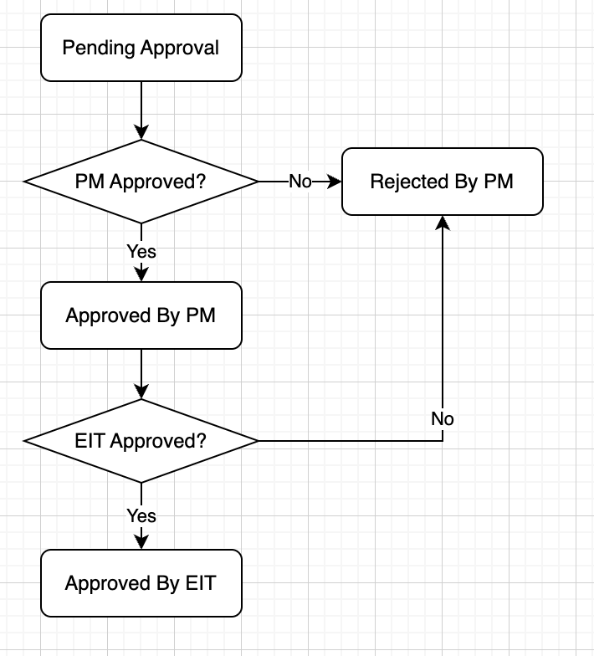

## Use Case 4: Cost Report

Indicatively every 6 months (for interim reports) and a little longer or less for the final report (according to the reporting periods calculation we provided to you), Projects should report on the activities carried out and the costs they have incurred.

The activity report is always filled in and submitted by the lead partner only. Each report (interim and final) is always composed of two parts: the narrative part (ie. the activity report) which is done by the lead partner only; the financial part (ie. the cost report) which is submitted by each partner directly. Important: the activity report should be linked with the cost reports: there should be a table in the activity report which fills-in automatically according to the costs reported by the single partners for each reporting period. This is important because the lead partner (in the narrative report) must comment on the reported costs as well. Additionally, the project manager must be able to see, on an aggregate level, the expenditure at project level. The overview should be per cost category, per task and per reporting period (but we can discuss about how it can be displayed according to what you can do).

|  |  |  |  |  |  |  |  |  |  |  |  |  |
| --- | --- | --- | --- | --- | --- | --- | --- | --- | --- | --- | --- | --- |
| Project duration | INTERIM report 1 | submission deadline | INTERIM report 2 | submission deadline | INTERIM report 3 | submission deadline | INTERIM report 4 | submission deadline | INTERIM report 5 | submission deadline | FINAL report | submission deadline |
| from 1 to 9 foremonths | na | na | na | na | na | na | na | na | na | na | M1-9 | M1-9+ 6 weeks |
| from 10 to 15 months | M6 | M6+6 weeks | na | na | na | na | na | na | na | na | M10-15 | M10-15 + 6 weeks |
| from 16 to 21 months | M6 | M6+6 weeks | M12 | M12+6 weeks | na | na | na | na | na | na | M16-21 | M16-21 +6 weeks |
| from 22 to 27 months | M6 | M6+6 weeks | M12 | M12+6 weeks | M18 | M18+6 weeks | na | na | na | na | M22-27 | M22-27 + 6 weeks |
| from 28 to 33 months | M6 | M6+6 weeks | M12 | M12+6 weeks | M18 | M18+6 weeks | M24 | M24+6 weeks | na | na | M28-33 | M28-33 + 6 weeks |
| from 34 to 36 months | M6 | M6+6 weeks | M12 | M12+6 weeks | M18 | M18+6 weeks | M24 | M24+6 weeks | M30 | M30+6 weeks | M34-36 | M34-36+6 weeks |

##### Assumptions

The PMO and Project Manager has access to NetSuite.

Each partner has the access to the customer center.

Cost Report is available in customer center.

Each partner can create their own cost report.

##### Scenario

This report is to be filled in by each project partner.

Partners should report the expenses following the cost categories foreseen in their budget.

A.1 EMPLOYEES (OR EQUIVALENT)

A.2 NATURAL PERSONS UNDER DIRECT CONTRACT

A.3 SECONDED PERSONS

A.4 SME OWNERS

B. SUBCONTRACTING

C.1 TRAVEL AND SUBSISTENCE

C.2 EQUIPMENT

C.3 OTHER GOODS, WORKS AND SERVICES

D.1 FINANCIAL SUPPORT TO THIRD PARTIES (INCL. PRIZES)

D.2 INTERNALLY INVOICED GOODS AND SERVICES

Once a cost report is submitted by partner, the financial team will receive a notification which mention the cost report should be approved.

Finance should be notified when the individual cost reports are submitted.

Finance has the power to approve/reject them (out of NetSuite)

Ideally, the system should mark in red costs which are not in line with the latest approved budget. Example: a partner reports costs under subcontracting but didn’t have any budget under that cost category; a partner reports 14K under travel, but the budget available under travel was 10K (i.e.. more than 30%). à what would fall under major changes should be marked (otherwise we are not able to track quickly if partners didn’t respect our rules)

Partners should not be able to see the costs reported by the other partners.

The Project Leader should be able to see the costs reported by all partners.

These costs report per partner, should be displayed in an aggregated way in the activity report (see below)

For the final Cost Report: after the set deadline the system should block the possibility to submit it.

Finance should be able to see if the activity report (point below) is assessed as white/green or red/orange. If it’s red, payments to the partners should not be allowed.

Implementation of Use Case #4:

1. Develop a script to send an email notification to the financial team.
2. Update the online form to highlight the field if it exceeds a threshold based on budget.
3. Update the NS screen to highlight the field if it exceeds a threshold based on budget. No separate script-generated page is required as we don’t have any sublist columns to highlight. Update the NS field label element.
4. Lead partner has access to all cost reports. Every partner can see its own cost reports. An extra filter should be added to the searches in the backend script.
5. Final cost report deadline should be calculated to forbid partners from submitting cost reports. The same logic to be applied also to interim cost reports.

### Use Case 5: Activity Report (interim and final)

The activity report is filled in by the lead partner only. Each report (interim or final) has an activity report.

Indicatively every 6 months (for interim reports) and a little longer or less for the final report (according to the reporting periods calculation we provided to you), Projects should report on the activities carried out and the costs they have incurred.

The deadline to submit this report should be 6 weeks after the closure of the reporting period.

##### Assumptions

The PMO and Project Manager has access to NetSuite.

Project Leader has access to customer center

##### Scenario

1st Part:

This report is to be filled in by the Project Leader only, but partners should be able to see it.

The following fields appear on the Activity report:

Interim activity report

* Overall activity status (level of completeness). [there are the values in the drop-down list: on track/minor delay/major delay]
* Progress of the activities up to the end of the reporting period and outlook for upcoming months [free text]
* Changes to the activities [free text]
* Status of outputs and deliverables [free text]
* Status of KPIs [table: here all the KPIs included in the application form should be displayed and the lead partner should provide explanations]

|  |  |  |  |  |  |
| --- | --- | --- | --- | --- | --- |
| KPI code | KPI name | KPI description | Target value foreseen | status | comment |
| [autofill] | [autofill] | [autofill] | [autofill] | drop-down list: on track/minor delay/major delay | [free text] |
| [autofill] | [autofill] | [autofill] | [autofill] | drop-down list: on track/minor delay/major delay | [free text] |
| [autofill] | [autofill] | [autofill] | [autofill] | drop-down list: on track/minor delay/major delay | [free text] |

* Cooperation among the project consortium partners [free text]
* Financial sustainability (if applicable) [free text]
* Gender and diversity [free text]
* Status of expenditure: here all the costs reported by the single partners should be displayed and the lead partner should be able to provide comments (the first 4 columns should be automatically filled in by the system – the only part to be filled in by the lead partner is the comment part)

|  |  |  |  |  |
| --- | --- | --- | --- | --- |
| Cost category | Budget [autofill] | Reported costs [autofill] | Exhaustion % [autofill] | Description |
| A. personnel [autofill] | [total budget foreseen in application form] | [total costs reported in this budget line by all partners in the project] | [percentage of exhausting on the budget] | [free text] |
| B. subcontracting [autofill] | [total budget foreseen in application form] | [total costs reported in this budget line by all partners in the project] | [percentage of exhausting on the budget] | [free text] |
| C1. Travel and subsistence [autofill] | [total budget foreseen in application form] | [total costs reported in this budget line by all partners in the project] | [percentage of exhausting on the budget] | [free text] |
| Etc. [autofill] |  |  |  |  |
| E. indirect costs [autofill] | [total budget foreseen in application form] | [total costs reported in this budget line by all partners in the project] | [percentage of exhausting on the budget] | No justification needed |
| Total [autofill] | [total budget foreseen in application form] | [total costs reported in this budget line by all partners in the project] | [percentage of exhausting on the budget] | No justification needed |

The lead partner and the Project Manager should be in any case have access to the individual costs reports of the single partners.

Final activity report

* Overall activity status (level of completeness). [there are the values in the drop-down list: from 10% to 100%, increasing of 10 each time]
* Progress and outputs achieved against the original plan [free text]
* Description of work implemented [free text]
* Status of KPIs [table: here all the KPIs included in the application form should be displayed and the lead partner should provide explanations]

|  |  |  |  |  |  |  |
| --- | --- | --- | --- | --- | --- | --- |
| Year | KPI code | KPI name | KPI description | Target value | Realisation value | comment |
| [autofill] | [autofill] | [autofill] | [autofill] | [autofill] | [autofill] | [free text] |
| [autofill] | [autofill] | [autofill] | [autofill] | [autofill] | [autofill] | [free text] |
| [autofill] | [autofill] | [autofill] | [autofill] | [autofill] | [autofill] | [free text] |

* Status of Deliverables:

|  |  |  |  |  |  |
| --- | --- | --- | --- | --- | --- |
| Year | DEL code | DEL name | DEL description | Completeness | comment |
| [autofill] | [autofill] | [autofill] | [autofill] | Drop-down 10%, 20% etc. up to 100% | [free text] |
| [autofill] | [autofill] | [autofill] | [autofill] | Drop-down 10%, 20% etc. up to 100% | [free text] |
| [autofill] | [autofill] | [autofill] | [autofill] | Drop-down 10%, 20% etc. up to 100% | [free text] |

* Status of Outputs:

|  |  |  |  |  |  |
| --- | --- | --- | --- | --- | --- |
| Year | OUT code | OUT name | OUT description | Completeness | comment |
| [autofill] | [autofill] | [autofill] | [autofill] | Drop-down 10%, 20% etc. up to 100% | [free text] |
| [autofill] | [autofill] | [autofill] | [autofill] | Drop-down 10%, 20% etc. up to 100% | [free text] |
| [autofill] | [autofill] | [autofill] | [autofill] | Drop-down 10%, 20% etc. up to 100% | [free text] |

* Cooperation among the project consortium partners [free text]
* Role of organisations: here there should be a prefilled table with the name of all partners and the space for the lead partner to include comments

|  |  |
| --- | --- |
| Partner | Description |
| Partner name [auto filled] | [free text] |
| Partner name [auto filled] | [free text] |
| Partner name [auto filled] | [free text] |

* Financial sustainability (if applicable) [free text]
* Gender and diversity [free text]
* Status of expenditure: here all the costs reported by the single partners should be displayed and the lead partner should be able to provide comments (the first 4 columns should be automatically filled in by the system – the only part to be filled in by the lead partner is the comment part)

|  |  |  |  |  |
| --- | --- | --- | --- | --- |
| Cost category | Budget [autofill] | Reported costs [autofill] | Exhaustion % [autofill] | Description |
| A. personnel [autofill] | [total budget foreseen in application form] | [total costs reported in this budget line by all partners in the project] | [percentage of exhausting on the budget] | [free text] |
| B. subcontracting [autofill] | [total budget foreseen in application form] | [total costs reported in this budget line by all partners in the project] | [percentage of exhausting on the budget] | [free text] |
| C1. Travel and subsistence [autofill] | [total budget foreseen in application form] | [total costs reported in this budget line by all partners in the project] | [percentage of exhausting on the budget] | [free text] |
| Etc. [autofill] |  |  |  |  |
| E. indirect costs [autofill] | [total budget foreseen in application form] | [total costs reported in this budget line by all partners in the project] | [percentage of exhausting on the budget] | No justification needed |
| Total [autofill] | [total budget foreseen in application form] | [total costs reported in this budget line by all partners in the project] | [percentage of exhausting on the budget] | No justification needed |

The lead partner and the Project Manager should be in any case have access to the individual costs reports of the single partners.

Implementation of Use Case #5-1:

1. Create an activity report custom record.

Sub records: Status of KPI, Status of Expenditure, Status of DEL, Status of Output

Form: Interim Activity Form, Final Activity Form

1. Update the online form to enable the lead partner to enter interim report records. Add a new tab to the form. Show only summary values of activity report on the sublist. Expose the Edit link to display a popup window that lets the lead partner enter all fields and child records.
2. Sub lists are automatically populated upon initiation.

Once the report is submitted by project leader.

2nd part:

The project manager registered on the CFP application form can approve or reject it.

When the project manager approves or rejects an activity report, he should fill in a “Performance assessment report”. This report should content 6 sections:

1. Technical Review (4 subquestions @EITUM please put the questions)

Project Manager put the answer of each question

Subquestions are:

* Status of Deliverables, Outputs and KPIs compared to project workplan and EIT Urban Mobility rules and guidance.
* Status of implementation of the activities.
* Quality, performance and impact of the outputs and KPIs.
* Performance towards financial sustainability (if applicable).

1. Compliance Review (2 subquestions @EITUM please put the questions)

Project Manager put the answer of each question

Subquestions are:

* Status of compliance with the obligations as described in FSA (EIT/EU co-branding, IPRs, ethics, commercial agreement, information obligations etc.).
* Status of fulfillment of all legal requirements of all partners.

1. Financial Review with one subquestion “Budget realisation compared to the financial forecast.”

Project Manager put the comments for each subquestions

1. Final Assessment: the project manager should select the color icon of each above part

|  |  |
| --- | --- |
|  | **Flag** |
| Technical review | Drop-down menu (green/white/orange/red) |
| Compliance review | Drop-down menu (green/white/orange/red) |
| Financial review | Drop-down menu (green/white/orange/red) |
| Overall result | Drop-down menu (green/white/orange/red)* |

1. General Comments (this is a normal text box where the project manager can summarise the final outcomes of the review)
2. Conditions: here the project manager should be able to create one row per condition given and, for each one, specify the deadline by which it should be fulfilled.

|  |  |
| --- | --- |
| **Conditions** | **Deadline** |
|  |  |
|  |  |
|  |  |
|  |  |

1. Recommendation for fast track

This section should be editable only for the final report, here the Project Manager should be able to tick yes/no and include some comments.

The Project Leader should be notified when the assessment report is available, when the Project Manager submits an assessment report, the leader partner is able to consult it through customer center.

The project manager can approving/rejecting/send back for modifications.

*If one of the indicate is in orange or red in assessment report, PMO registered on the CFP application form will be notified.When something is red/orange the project manager should not be able to send the assessment report to the lead partner. The workflow should be the following: the project manager approves the report; if it’s white/green the report goes to the lead partner; if something is orange/red, the report goes to PMO and PMO should approve it before it can go to the lead partner.

|  |  |
| --- | --- |
|  | **Flag** |
| Technical review | Drop-down menu (green/white/orange/red) |
| Compliance review | Drop-down menu (green/white/orange/red) |
| Financial review | Drop-down menu (green/white/orange/red) |
| Overall result | Drop-down menu (green/white/orange/red) |

Implementation of Use Case #5-2:

1. Add a set of fields that represents the performance assessment. Add a new tab to the final activity report.
2. The Performance Assessment Report tab has 6 sections and 1 sublist. “Assessment: Condition” subrecord is required and needed to be attached to the activity report.

Alternative solution: Create a separate custom record type that holds the performance assessment.

### Use Case 6: After the closure of the project

Once the project is close, all the tabs on application form will be frozen. Partners can only create the KPI in a specific part. A new tab will appear with all the KPI type and necessary information (KPI record).

EITUM can unfrozen all the element in different tabs

Implementation of Use Case #6:

1. Only a specific KPI section on the online form is editable.
2. Create a checkbox to indicate the fields and sections need to be editable on the online form. Or create a new status, so that EITUM can change the status temporarily to get inputs from partners after the CFP App is closed.

# Legacy reporting

Project Leaders should be able to still do some reporting up until 5 years after the official project end. This reporting should be linked to some “legacy” KPIs – ie. some KPIs will have a submission deadline that goes after the project closure. Apart from KPIs we have also some kind of DEL – ie. the lead partner should be able to have a free text box and upload a document (not linked to any KPI).

Once the project is closed,all the tabs should be frozen. A new tab will be appeared for partners. the KPI is available for them, all types of KPIs are seletable. (only on customer center)

The system should regularly notify (for example once a year) the Project Leader and the Project Manager in the Thematic Area about these pending. KPIs Pending will mean that there is a KPI (with its due date) which appears as not submitted.

The submission of these “legacy” KPIs should follow the same logic of the KPIs submission (point 2.1): the main difference is the fact that the deadline is after the project is officially closed. Yes the main difference will be the fact that the submission deadline is after the project closure. Some of these KPIs will be the same we have for the “normal” reporting.

In all the project, all the KPI should be put in before the end date of project. Once the project is closed, the system should forbid partners to change the form. The legacy reporting section should remain editable and in that section, it should be possible to add new KPIs (it should be possible, from a drop-down menu) to select any of the KPIs we have (not only the ones linked to the original CFP).

Implementation of Legacy Reporting:

1. Legacy Reporting KPI section is required to enable partners to add new KPIs.
2. Saved search-based notification logic will be put in place for pending KPIs.

# High-Level Solution Proposal

This customization will leverage NetSuite’s Journal Entry functionality to record the allocation and payments of grants which will be automated with a SuiteScript and custom records. When either a Grant Payment record, or a Grant Allocation record is created, the script will automatically create a new Journal Entry record based on the amounts entered, and which record was created.

|  |  |
| --- | --- |
| Solution Element | High-level description |
|  |  |
|  |  |
|  |  |